1. Compare the impact of pumping on the single layer model vs the multi layer model. What physical explanation do you have for the differences?

The difference that can be seen is that the layers prevent flow from going in certain directions like how flow doesn’t go upwards or downwards in the three layer flow as easily as the one layer flow so the upper layer still has a decent amount of water flowing through it while the one layer one has a more noticeable cone of depression

1. Repeat the three layer simulations putting the well in each layer (i.e. once in the bottom once in the middle and once in the top) provide plots and discussions comparing and contrasting your simulations. Provide at least one plot where you have all of your runs in the same figure.

It can be seen in the graphs below that depending on where the well layer is flow will do certain things lik in layer one flow almost stops altogether as it has the lowest k values of all the layers. Layer 2 is the original run and layer 0 has the most apparent cone of depression.

1. Layer 2 well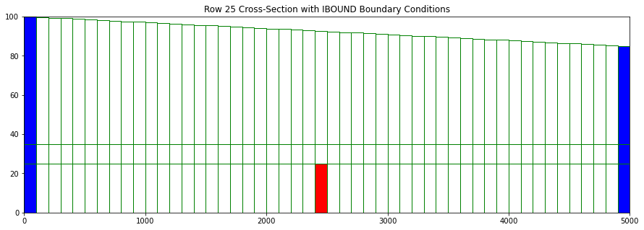
2. Red is the well depth
3. Cross sectional flow graphs
4. One segment variable head and flow height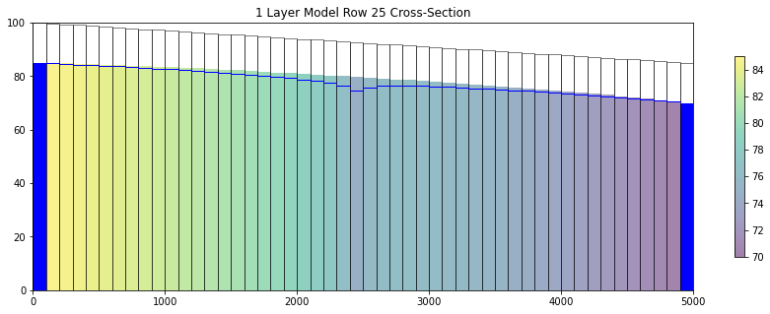
5. Three segment variable head and flow height
6. 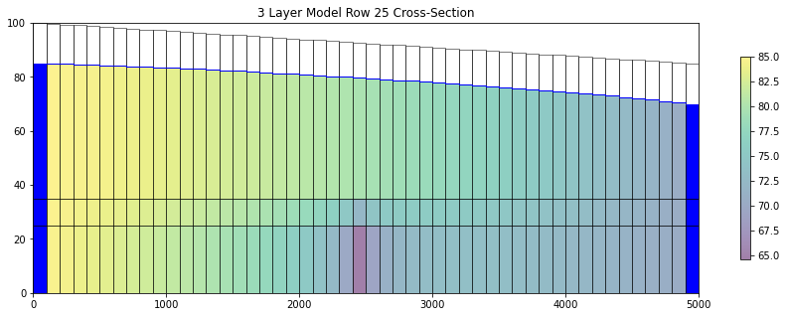
7. Head transect head transects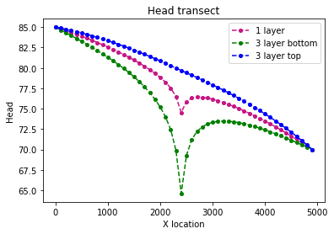
8. Head contour and flow path one segment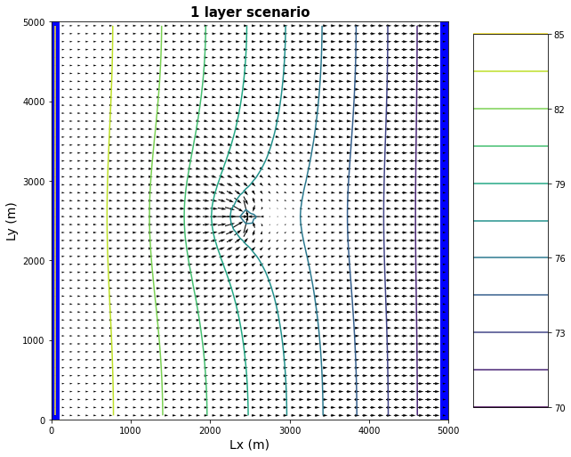
9. Head contour and flow path three segment 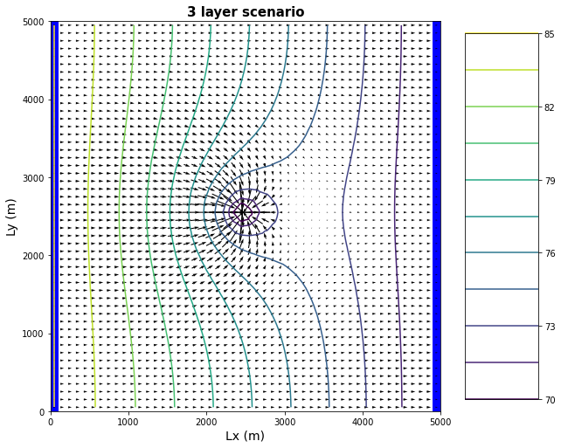
10. Layer one well graphs
11. Cross section of of the layered model
12. 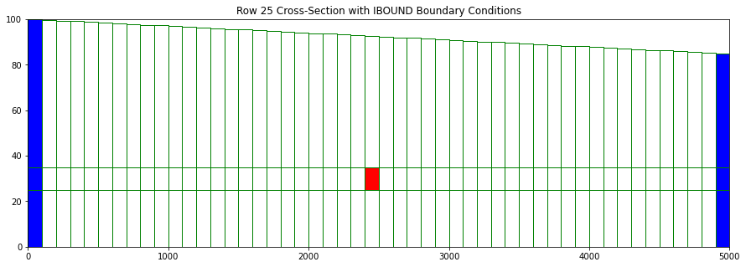
13. Three layer variable flow and head height graph in layer 1 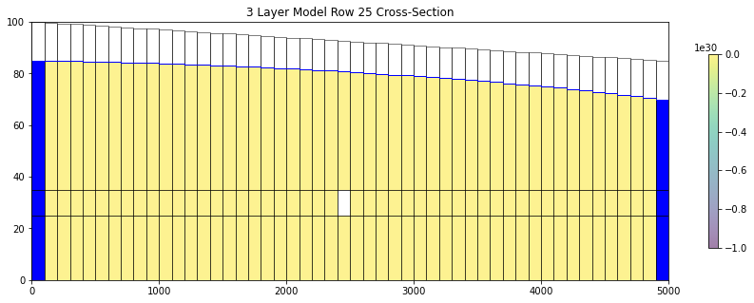
14. Head transects layer 1
15. 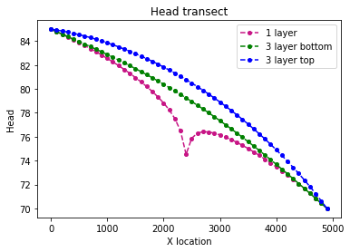
16. Head contours map layer 1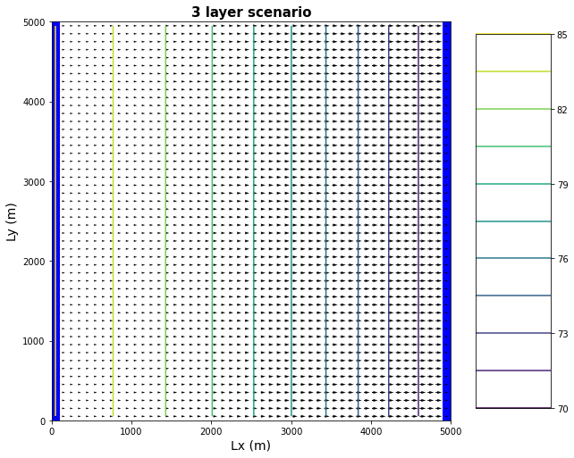
17. Layer 0 graph
18. Cross section layer 0 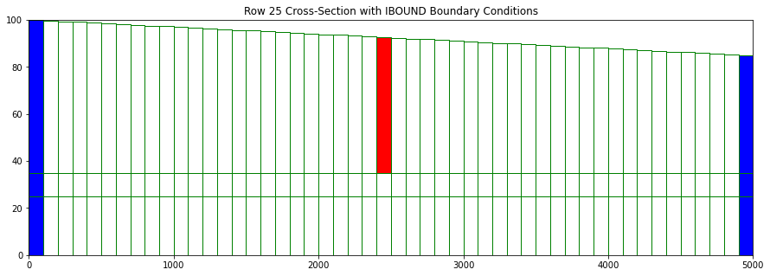
19. Layer 0 flow and head cross section 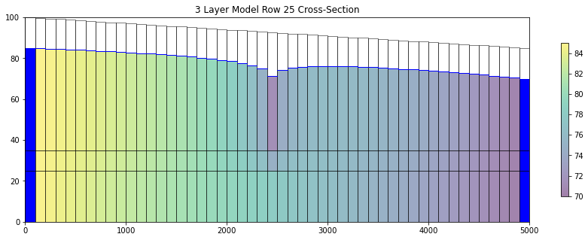
20. Head transect for layer 0 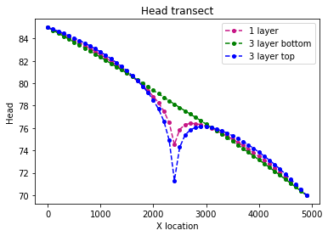
21. Layer 0 head contours
22. Change the properties of your three layer model so that it matches the 1 layer model (but still has 3 layers) put the pump in the bottom layer and compare and contrast with your one layer solution. How does your answer to this challenge compare with your answer to the first?

For all intense and purposes it seems like the flow through both of the systems looks exactly alike.

1. Modify the topography of your domain so that it is no longer sloping left to right (you can make it a valley or have it sloping the other way, whatever you want). Re-run you 1- and 3-layer solutions and explain any differences you do or don't see. You still see the well drawing from the layer 3 and a smaller cone of depression happen from it and a truer cone of depression from the one-layer model while the flow goes towards the center of the map otherwise making the flow from both edges no longer a source and sink but two sources.
2. Layers: Why do we want multiple layers in our groundwater models? Compare and contrast the different approaches to vertical discretization (briefly describe different approaches and discuss their strengths and weaknesses).

Multiple layers in a ground model can help show unconfined and confined groundwater flow.

1. Discretization: What are the pros and cons of adding more layers to a model? Are there considerations for vertical discretization that are different from horizontal discretization?
2. Stream Aquifer Exchange: How is water exchanged between a stream and an underlying aquifer? Include the following concepts: (dis)connected streams; streambed hydraulic conductivity; boundary condition type; and coupled models.